Strategy Pattern

It identifies the problems that arise in case of inheritence. Inheritence work great as long as the properties (method implementation or variables) travel downwards. But it created the problem when we want to access the properties at horizontal level.

Lets See this with Example
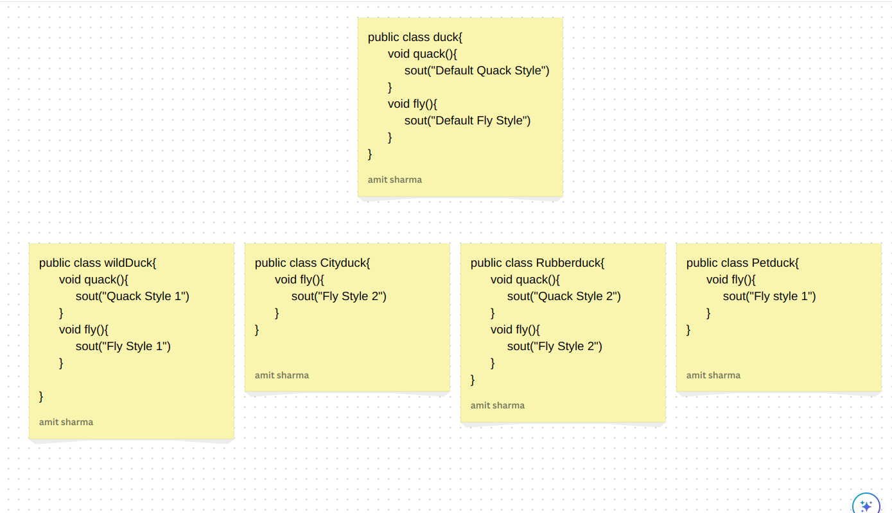
Base Class : Duck
Child Class: WildDuck, CityDuck, RubberDuck, PetDuck

WildDuck and PetDuck has same fly behaviour but implemented 2 times and there is no way we can share the code between these 2 classes on horizontal level. What we can do to solve this problem is create another base class which will implement the fly behaviour and also inherit that class into WildDuck and PetDuck(Multiple Inheritence). And it is problem as we can not use the multiple inheritence in java.

Approach to Solve this Problem:
Instead of directly writing the implementation of methods inside the base Duck Class we will create the strategy (Means create the interface of each method and that interface will be implemented by another classes and in this way we can created multiple implementation of each function) and to use those function’s interface inside our Duck class we will use the reference variable(composition).
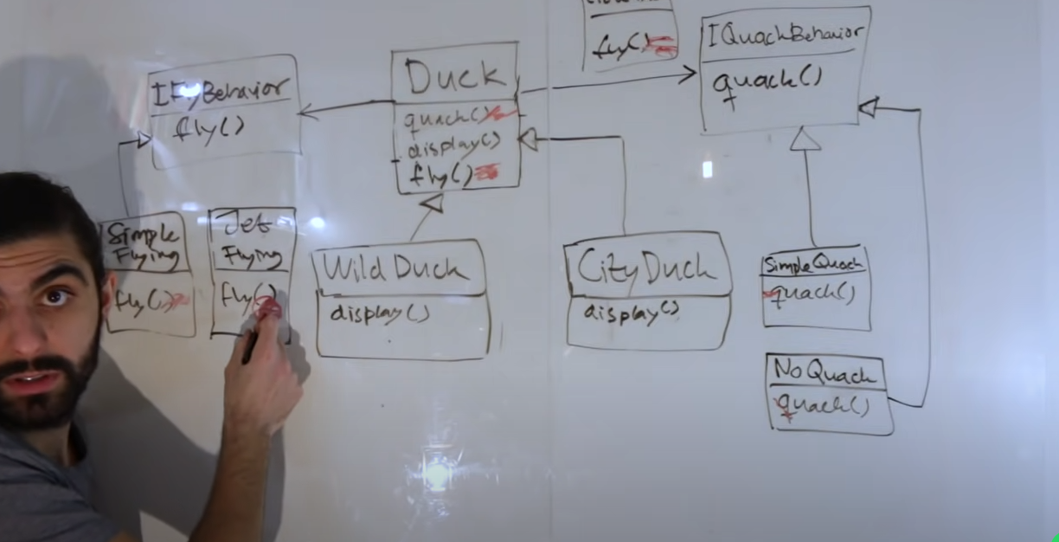
In the right side we have IQuackBehaviour interface which is implemented by SimpleQuack and NoQuack.
In the Left side we have IFlyBehaviour Interface which is implemented by Simple Flying and JetFlying.

In Duck Class we will create the reference variable of IQuackBehaviour and IFlyBehaviour and at run time we can decide what should be the implementation of each function.

